Specialist Mathematics Unit 4 Investigation 3, 2016
Partial & Numerical Integration
Take Home Section – due Tuesday 21 June

Validation of your findings will take place on that day, with 100% weighting on the validation. Part of the validation will allow calculators for Numerical Integration, part will not. No notes will be allowed in the validation.

Name: _______________________________

Integration by Parts
Now 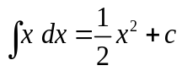 and 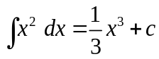
It is apparent that 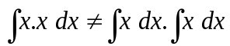
Therefore the integral of a product is not the product of the individual integrals.
That is 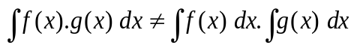

Integration by Parts is a technique for simplifying integrals of the form
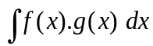
Now if f(x) and g(x) are differentiable functions of x, the Product Rule says
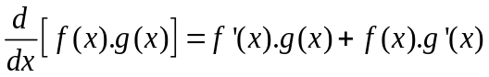
In terms of indefinite integrals this equation becomes
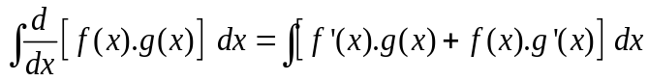
= 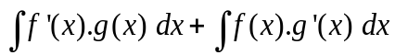
Rearranging we get
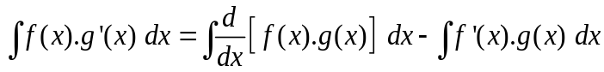
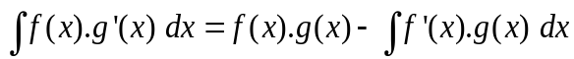 - This is the Integration by Parts Formula
The examples below illustrate how the technique is used.
Example 1 Find 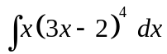
Let f(x) = x and g’(x) = ( 3x -2 )⁴
Then f’(x) = 1 and 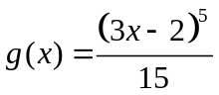

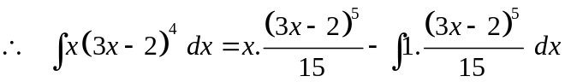

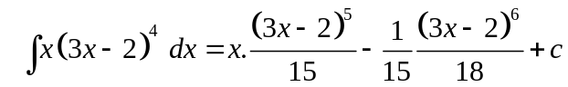

Example 2 Find 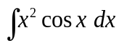

Let f(x) = x² and g’(x) = cos x
Then f’(x) = 2x and g(x) = sin x

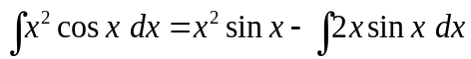
The integral on the RHS is still a product, so we repeat the process for
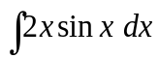

Let f(x) =2 x and g’(x) = sin x
Then f’(x) = 2 and g(x) = - cos x
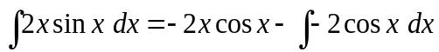
= 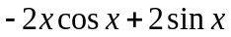

Hence
= 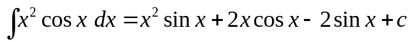

Numerical Integration

A useful application of integration is in finding the area bounded by a function and the horizontal axis between certain limits.

The area bounded by the curve 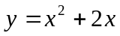 and the x - axis from x = 0 to x = 3 can be evaluated by the definite integral:

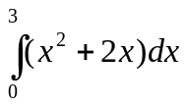
This calculation is only possible if we can find a function which has 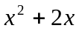 as its derivative.
Where it is not possible to find such a function, a mathematician resorts to techniques of numerical integration to obtain approximations for an integral and is able to control the degree of accuracy.
The Greek mathematician Archimedes (287-212 BC) was able to calculate the area of segments of a parabola without any knowledge of modem calculus. His technique was called "method of exhaustion"!

A QUESTION OF ACCURACY

This investigation involves a variety of numerical methods used to evaluate integrals. Throughout you are required to give final results correct to3 decimal places. To achieve this degree of accuracy, you will need to carry extra decimal places in earlier calculations.

SUMMATION OF RECTANGLES
It would be wrong to think that we are now able to find the definite integral of any function that we may be given.
For some functions it is not possible to find the integral. For others, whilst it is possible to find the integral, the advanced techniques required are beyond the level of this course. However, even for these functions, we can obtain an approximation for the definite integral by summing rectangular areas.

For y=f(x) shown in the diagram: 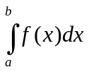 the sum of the areas of the rectangles. If we increase the number of rectangles we improve our estimate. | 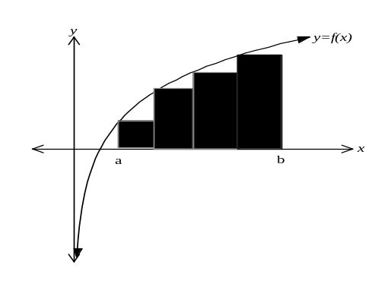
TRAPEZOIDAL RULE
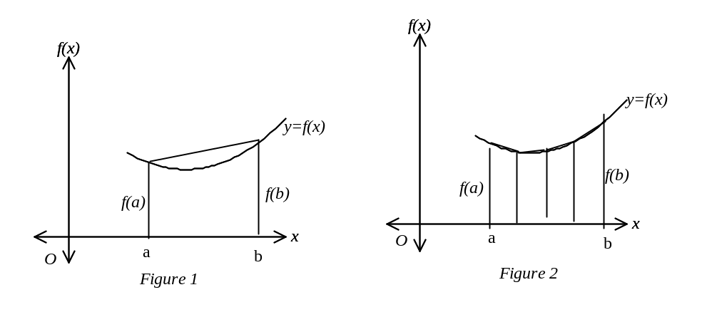
The simple application of the trapezoidal rule substitutes a straight line in place of the curve between x = a and x = b as shown in figure 1. The area of the trapezium is used as an approximation to the area under the curve.
Using the formula for the area of a trapezium as ½ of the sum of the parallel sides times the distance between them, then
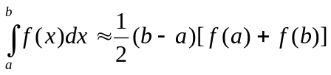
The area bounded by the curve and the line in Figure I indicates the error involved. If the graph of f(x) were a straight line, there would be no error.
The error can be reduced, but not completely eliminated, by subdividing the interval [a; b] into n sub-intervals of equal width, 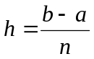 and constructing a trapezium on each sub-division as shown in Figure 2. In general, the more the sub-divisions, the smaller the error. In this case
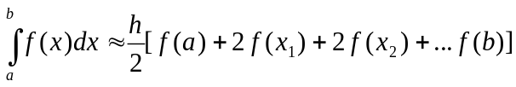
SIMPSONS RULE

The trapezoidal rule approximates the curve with a straight line or a series of straight lines on the interval 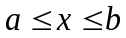.Simpson's Rule is based on the fact that we replace the given function by a quadratic function, i.e. we replace the graph of the given function from x = a to x = b by an arc of a parabola which intersects the given curve at x = a,
x =b and the mid-point 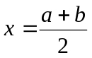 as shown in the figure below.
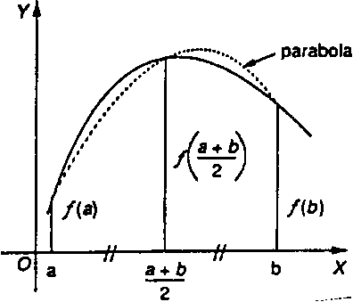
It can be proved that the area under the parabola through these three points is
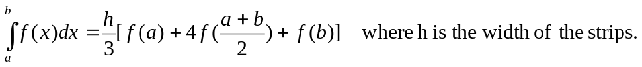
When the area bounded by a curve, x-axis, x=a and x=b is divided into n strips of equal width, where n is even, we can show that the area
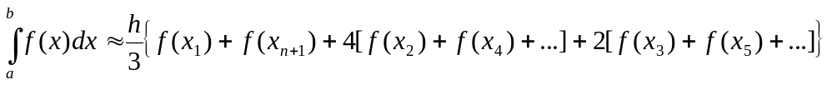
or simply 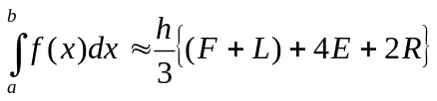
where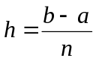, F is the left boundary of the first strip, L is the right boundary of the last strip, E the sum of even boundaries and R is the sum of the remaining boundaries.

Take Home Questions. Complete these on separate paper.

Using the method of Integration by Parts, determine the following indefinite integrals:

1. 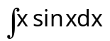
2. 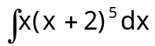
3. 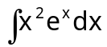

4. 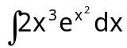
5. 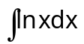

Trapezoidal Rule:
6 a) Draw a diagram which shows the area under the curve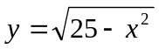 being approximated by an equal width partition of 5 trapeziums.

b) Write a general trapezoidal rule for 5 sub-intervals.

c) Use your formula to find the approximate area bounded by on the interval [0; 5] using five trapeziums of equal width.

7. Calculate the value of 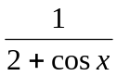 for 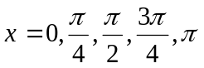 and using the trapezoidal rule with four strips estimate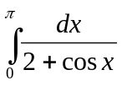.
Simpson’s Rule:
8. Use Simpson's Rule with four strips to approximate the integral 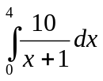

9. Use Simpson's Rule with six strips to approximate the integral

